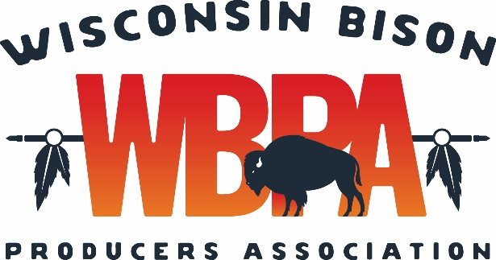
Registration for the Annual Conference & Membership Meeting
February 6 - February 7, 2026
Name(s)______________________________________________________________________
Address______________________________________________________________________
_____________________________________________________________________________
Phone Number________________________________________________________________
E-Mail Address________________________________________________________________
Registration Fees WBPA Members $70. Non-Members $90. Students $10.
Under 18, free.
(Please indicate how many will attend)
Deadline 1/20/26
(Registration fee includes Friday social; Saturday continental breakfast, transportation to JM Watkins Meats, bison lunch, and evening bison steak dinner. Hotel and bar are not included in the fee.)
_______ No. WBPA Member Registrations _____No. of Non- Member Registrations
_____No. Students ______ No. Under 18
Payment Enclosed ___________ Bill Me ___________
Send registration and payment to:
Mandy Hein
2874 Spring Drive
Rhinelander, WI 54501
Hotel Reservations can be made at the Holiday Inn Eau Claire South
4751 Owen Ayres Court, Eau Claire, WI 54701
For Reservations Call 715-830-9889
Deadline to ensure rates and availability is January 7, 2026
Room rates are $130.00/night plus tax
Make sure to mention that you are with the Wisconsin Bison Producers Association attending the conference to get this group rate. The Group Code is: BIS

